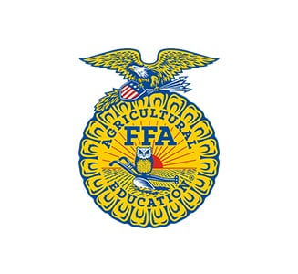***LEADERSHIP CONFERENCE SCHOLARSHIP APPLICATION***

The Nebraska FFA Alumni and Supporters are proud to support FFA chapters and members who express the desire to further their leadership skills and abilities.

There are many opportunities through FFA to build both students’ and chapters’ abilities to be effective leaders within their local communities. These programs teach the participants valuable skills through personal development. Qualifying conferences or opportunities for this scholarship include leadership-geared topics such as effective communication, strategic thinking, vision making, and adaptability. Some examples are WLC, Leadership Series (Mission Conference and Impact Conference), COLT, Edge, NAYI, Nebraska State FFA Convention, National FFA Convention, and Spring Leadership Conference. Any conference, workshop, or event oriented towards leadership will be considered for this scholarship.

These scholarships are awarded annually to selected local FFA Alumni and Supporters Chapters who apply for their FFA Chapter. We encourage every active Alumni & Supporters Chapter to consider applying for this scholarship. Advancing leadership knowledge is a worthwhile experience for all students, the future of agriculture, and our world!

Applications are evaluated on thoroughness and compliance to the stated leadership objectives. If selected for a scholarship, a letter summarizing your experiences is required by November 30 of the award year, in order to reapply the following year.

Completed Applications are due on **DECEMBER 1st**

Please mail or email application to:

Rachel Tagge, Awards Chairman

Nebraska FFA Alumni & Supporters

PO Box 151

Osceola, NE 68651

Email: rachel.f.tagge@gmail.com

**LEADERSHIP CONFERENCE SCHOLARSHIP**

**Name of FFA Alumni & Supporters Chapter: _______________________**

**Conference Planning to Attend: _____________________________   ___**

**Amount Requested: ________________________________________    ___**

List 3 events or joint operations between your local FFA chapter and your local FFA Alumni & Supporters Chapter. These events should exhibit examples of leadership and teamwork.

**1.**

**2.**

**3.**

Describe the importance of student development to your FFA Alumni & Supporters Chapter. What other action has your chapter taken to improve the leadership skill sets of students?

Please provide a brief statement (1/2 page) about your goals while attending this event. This can be from either the chapter’s or individual student’s perspective.

Include the following:

1. What do you hope to learn?
2. How will this help your growth and personal development?
3. What motivates you, or the chapter to attend?
4. Why should we sponsor your experience?
5. What do you hope to gain by attending?

Please have this application signed and returned to the Nebraska FFA Alumni & Supporters Awards Chair by December 1st.

Digital submission may include typed signatures.

____________________________________________

Local FFA Alumni & Supporters Chapter Officer Signature

____________________________________________

Local FFA Advisor’s Signature